|  |  |
| --- | --- |
| Date | 9 October 2022 |
| Team ID | PNT2022TMID51074 |
| Project Name | AI Based Discourse for Banking Industry |

**PROJECT DESIGN PHASE II**

**CUSTOMER JOURNEY MAP**

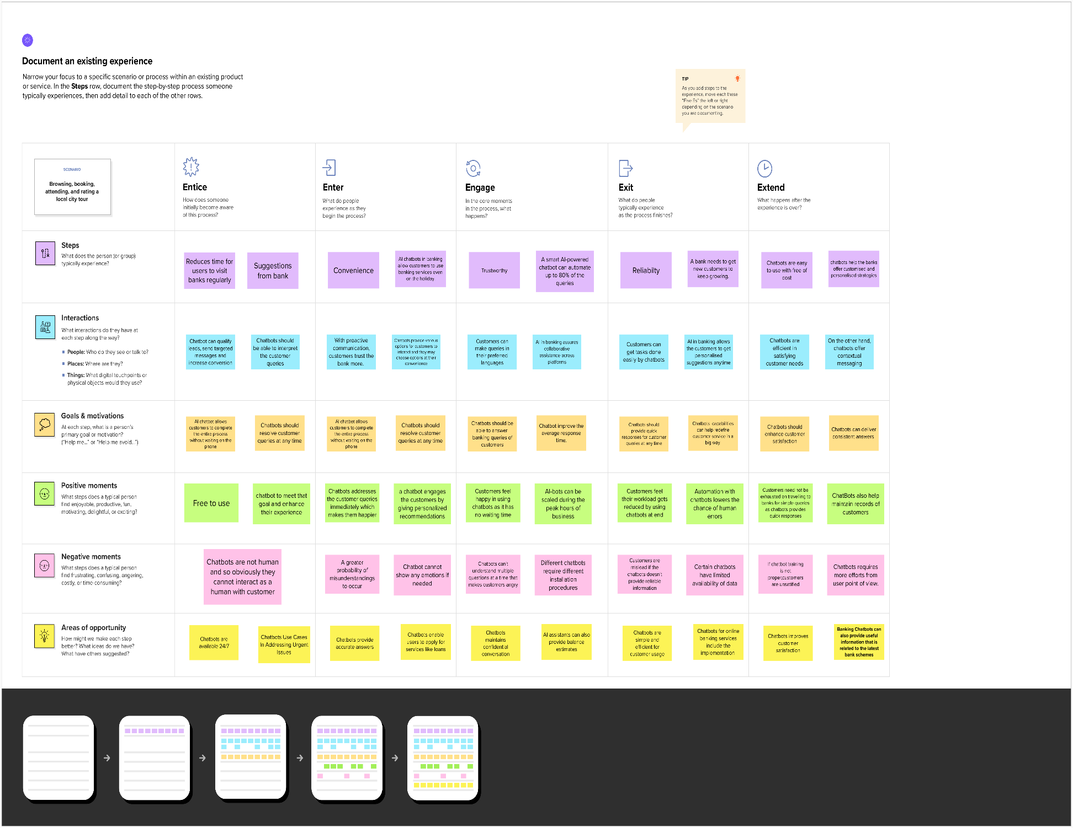

**Customer Journey Map**

<https://app.mural.co/invitation/mural/aibaseddiscourseforbankingin9468/1667491286471?sender=ua07c60ee3a493ea8cb817251&key=3722b2bc-a6a5-4934-9d86-233d7005822a>